Culture Monster
ALL THE ARTS, ALL THE TIME
« Previous | Culture Monster Home | Next »
Art review: "Karl Benjamin and the Evolution of Abstraction, 1950-1980" at Louis Stern Fine Arts
November 17, 2011 | 6:00 pm

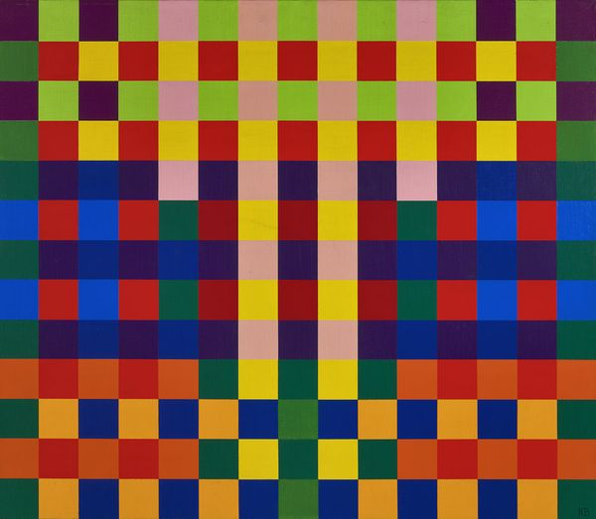

Over the last eight years, Karl Benjamin has had four solo shows in Los Angeles, two museum surveys in Southern California and two out-of-town exhibitions. His paintings have also been included in 36 group shows. That’s a busy schedule. It’s all the more remarkable because Benjamin has not made a painting since 1996, when the physical demands of his exacting abstractions exceeded his body’s capacity to meet them.
Even more impressive than the number of Benjamin’s exhibitions is the range and power of the paintings in them. At Louis Stern Fine Arts, “Karl Benjamin and the Evolution of Abstraction, 1950-1980” is exemplary. Filled with canvases never before exhibited and others you can’t get enough of, the sensational show traces a path through the 85-year-old’s oeuvre that is eye-opening, even to viewers who follow his work closely.
Part of that is due to Benjamin’s work ethic. For decades, he painted with purposefulness that bordered on recklessness, eagerly embarking on new bodies of work immediately upon completing old ones, which he squirreled away in a storeroom. Over the years, that storeroom became a treasure trove, which Benjamin’s recent exhibitions dig into.
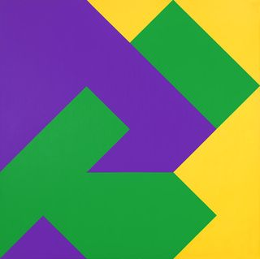

In the 1950s, ’60s, ’70s and ’80s, Benjamin exhibited less frequently. Sales were rare. Living in Claremont, he fell into a way of working that was self-sustaining. Rather than relying on feedback from others, he made sets of works that carried on conversations among themselves and between and among other sets.
Always lively, sometimes feisty and often eloquent, these conversations looped back to earlier compositions, formats and palettes only to break away from what such setups had delivered. This is evident in Benjamin’s six stunning paintings from 1975, where diagonals and right angles join forces to transform otherwise vulgar color combinations into weirdly sophisticated instances of just the right stuff. Logic and intuition intermingle in these rigorously beautiful works, whose pleasures are sensible and mind-blowing.
Color and structure are Benjamin’s bread and butter. His talent (or genius) is to put them together so deliciously that you have to see them for yourself. And once is not enough.
--David Pagel
(Louis Stern Fine Arts, 9002 Melrose Ave., West Hollywood, (310) 276-0147, through Dec. 24. Closed Sundays and Mondays. www.louissternfinearts.com)
Images: Top, Karl Benjamin, "#31," 1965; bottom, Karl Benjamin, "#34", 1968. Credit for both: Louis Stern Fine Arts.

