KARL BENJAMIN – HARD EDGE PAINTER
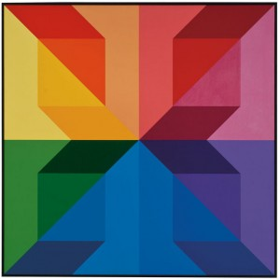

Long before Karl Benjamin (born 1925) began his influential career as a California Hard Edge painter, he had aspirations of becoming a writer. A student at the University of Redlands in 1946, fresh off a three-year tour as a naval officer in World War II, Benjamin was likely unaware of the boundless vocabulary of color – rather than words – he would construct over a 60-year painting career. He graduated three years later with teaching credentials and a degree in literature, philosophy, and history. Married with a family, Benjamin began teaching at an elementary school in Bloomington, California, where he was required to teach art for at least 45 minutes a week. Preferring to teach literature and writing, he ignored the arts requirement until his principal intervened. Benjamin begrudgingly passed out crayons and paper and famously announced to the class, “Fill up the space with pretty colors and don’t mess around.”
Inspired by his students’ abstract creations as well as visits to local museums and galleries, two years later he started painting his own color experiments. From then on, while teaching elementary school in Claremont for thirty years, he steadily painted distinct compositions of subtly changing hues and interrelated shapes. Only three years after his first venture into painting, he achieved a solo exhibition at the Pasadena Art Museum in 1954. Five years later he was
featured in the 1959 Los Angeles County Museum of Art exhibition “Four Abstract Classicists” along with Lorser Feitelson, John McLaughlin, and Frederick Hammersley, which later traveled to Great Britain under the name “West Coast Hard Edge.” He continued teaching at the elementary school level for thirty years until 1977, and two years later he was appointed Professor of Art at Pomona College. Throughout the remaining decades of the twentieth century, Benjamin achieved numerous honors and exhibitions, including two National Endowment for the Arts grants in 1983 and 1989.
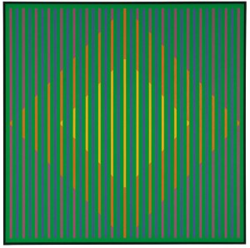
Some of his earliest paintings, including Yellow Landscape (1953), articulate his Abstract Expressionist influences, though Benjamin finds his own voice in undulating landscapes growing through an expansive palette of corresponding colors. After 1954, his Hard Edge style had become more geometric, characterized by “an intensive exploration of color,” as seen in V.S. (1960), a collection of alternating stripes of warm color that congregate against an evolving pink and gray background. Benjamin was known to work on several different paintings at a time, reusing specific shapes and colors. For example, ten years after V.S., he revisits stripes in a more visually jarring Op Art composition, #7 (1977). While many of Benjamin’s works seem to follow the symmetry and boldness of Op Art, Benjamin in 1986 commented, “I am an intuitive painter, despite the ordered appearance of my paintings, and am fascinated by the infinite range of expression inherent in color relationships.”
LAMA INTERVIEW WITH KARL BENJAMIN
APRIL 30, 2012
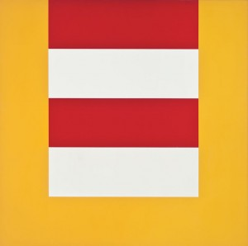
Paul Des Marais: Can you tell us about your time as a teacher? I read somewhere that when you were forced to teach more art in the classroom, you gave the students crayons and said, “Just fill up the space with pretty colors and don’t mess around.” Soon afterwards you started painting on your own.

Karl Benjamin: I was interested in the pictures that the kids were doing. Like the poetry they wrote (which was more my familiar field at that time) they made beautiful work coming from a very unsophisticated background with little access to current culture – it came from deep within them when they were given permission to free it from preconceived notions of what art was supposed to be. It made me feel like, “If they could do this, so could I.” And that inspired my confidence in painting myself. I knew an art professor at the University of Redlands who was very supportive in what I was trying to do and encouraged me to utilize what was left on the GI Bill in order to have the time to study art. Afterwards I continued to teach elementary school for 30 years and painted every day at home. Eventually, I was asked to apply as a professor of art at Pomona College and Claremont Graduate University. By that time I had amassed a sizeable exhibition record. I taught there until retirement.
PD: We’re lucky to have one of your earliest and most stunning paintings, Yellow Landscape (1953). What was your inspiration for this piece?
KB: It’s one of my favorite paintings to this day. It was not a painting of a particular place, it made a particular place. The surreal aspect of the painting was a way station on the way to 20th century painting. To rise above Realism was paying a debt to non-objective painting.
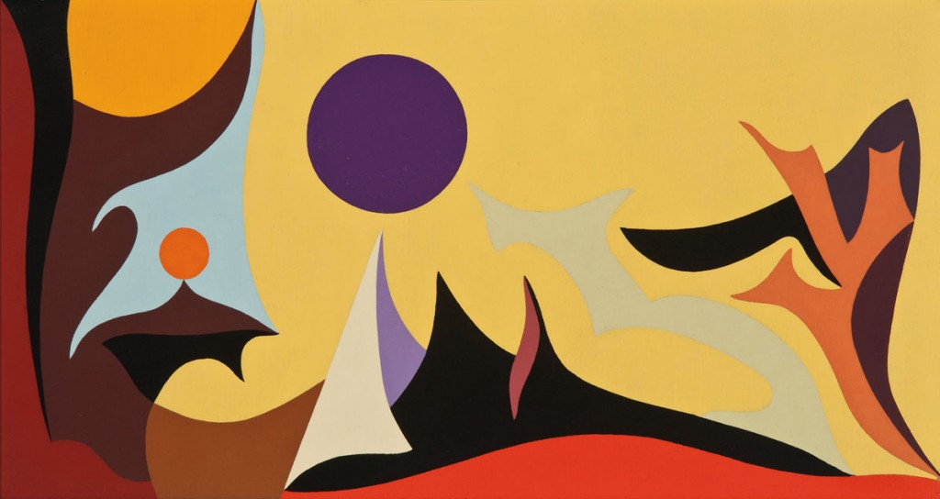
PD: At the time, did you, Frederick Hammersley, Lorser Feitelson, and John McLaughlin realize the potential impact you could make on the current art scene? Tell us a little bit about that first meeting that led to the “Four Abstract Classicists” show at LACMA in 1959.
KB: Would make, not could make. There are no short answers to this question. We said, “There’s something new here.” A new “style” is too arbitrary a word, as if we were intellectually choosing how to paint. We knew each other’s painting and felt we were kindred spirits even though we were painting independently and had arrived there separately from different backgrounds. But we wanted our work to be shown and for people to see it. Peter Selz was a teacher and he wanted to show this new emerging type of work, so he pulled us together. The work actually all came from very different places inside each of us.
PD: Hammersley used his “hunch” method to paint while Feitelson seemed to draw inspiration from the human body. Did you have a method or process you’d revisit for each painting or was your style more free form?
KB: I was trying to paint like all the new things I was seeing. I’d see an artist that I liked and try to do that kind of painting. This was at the very beginning because I was by myself, not a student. In some paintings, I’d start with charcoal lines on the canvas; sketch, change, and erase until the shapes felt right. There would be an intuitive urge to paint red or pink or whatever; the exact color would decide itself as I mixed it. Then the next color I mixed would be in accordance with the previous one. Some paintings, like the triangles, were series that were expressing a pre-determined idea, although sometimes with randomly chosen placement. The specific shades and particulars of the color were all based on intuition, which ones were right.
LAMA wishes to thank Karl Benjamin and his family for graciously giving us their time and insight.
Interview and essay by Paul Des Marais, contributing writer for LAMA
Each of these five works shown on this page will go up for auction on May 6, 2012 in the Modern Art & Design Auction. For bidding inquires, please email a LAMA representative or call 323-904-1950.
Literature: Louis Stern Fine Arts. Karl Benjamin and the Evolution of Abstraction. West Hollywood: Louis Stern Fine Arts, 2011. Print. Louis Stern Fine Arts. Karl Benjamin: Paintings from 1950-1965. West Hollywood: Louis Stern Fine Arts, 2004. Print.

Retrieved via http://www.lamodern.com/auctions/may-2012/karl-benjamin-interview/ on May 4, 2012

